CURRICULUM VITAE
GOUTAM.
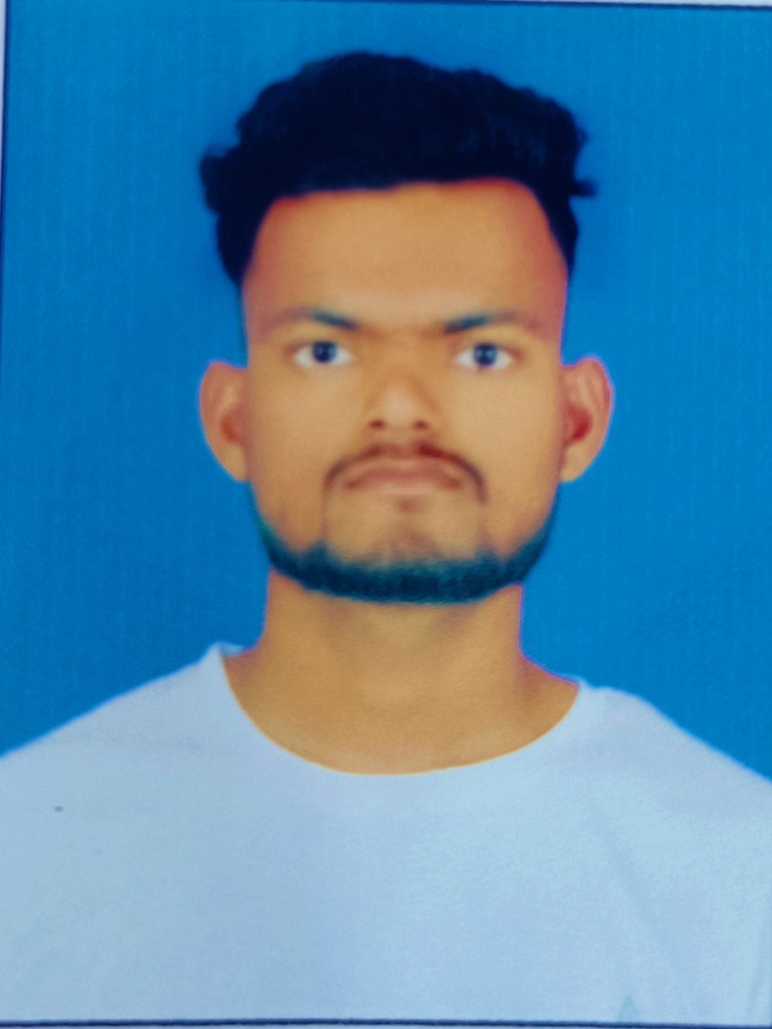
Ph No: +918050777685, +917676811129.
E-mail ID: gautampawar705@gmail.com.
Permanent Address:
Rest camp tanda, ward no:4.
Wadi(j/n), Dt: Gulbarga.
Karnataka 585225.

CAREER OBJECTIVE:

To work in an environment which encourages me to succeed and grow professionally where I can utilize my skills and knowledge appropriately. I seek challenging opportunities where I can fully use my skills for the success of the organization.
EDUCATIONAL QUALIFICATION:

- ITI (Diesel mechanics) from YADGIR POLYTECHNIC YADGIR college Affiliated to Department of industrial training and employment Karnataka-2020.
- ITI (INSTRUMENTATION) from HKE society Affiliated to Department of industrial training and employment Gulbarga-2019.
- S.S.L.C from Karnataka state board-2015.

HIGHER QUALIFICATION (B-COM )
- Bachelor in Commerce (B-COM) from Siddarth degree college wadi sine 2019 - Till -2022

INTERESTED IN

- BPO Business Process Outsourcing
- SAP Finance and Controlling

DriVING Licence (heavy batch):

DL NO.: KA32 20180007084
Valid Till: 13/05/2038(NT).

SOFTWARES PROFICIENCY:

- MS Word
- MS PowerPoint
- MS Excel.

PERSONAL PROFILE:

Father’s Name : Tulsiram pawar
Marital Status : Un-married
Sex : Male
Date of Birth : 24th of Sep 1999.
Language Known : English, Hindi & Kannada.
Nationality : Indian.

PASSPORT DETAILS:

Passport No. : S6326723.
Place Of issue : Bengaluru, Karnataka.
Date Of issue : 09-10-2018.
Valid Up to : 08-10-2028.

I hereby certify the above information is true and correct.

GOUTAM.

